|  |
| --- |
| 新东方在线英语学习 |
| 新概念 1 册 |
| Lesson81-82 |



扫一扫。更多有趣的英语资讯。

# Lesson 81 单词讲解

1. bath: 洗澡 bai si

have a bath

He had a bath at 11:00 pm. last night.

1. nearly: 几乎、将近

I’m nearly ready. 我马上就好

I nearly die.

实前系后

1. ready: 准备好的

Are you ready?

1. dinner: 正餐、晚餐

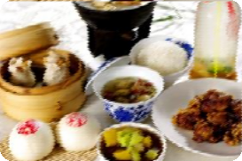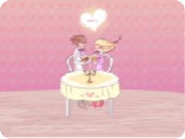

Breakfast lunch dinner

1. restaurant: 餐馆
2. ruai zhu ang te

at the restaurant

1. 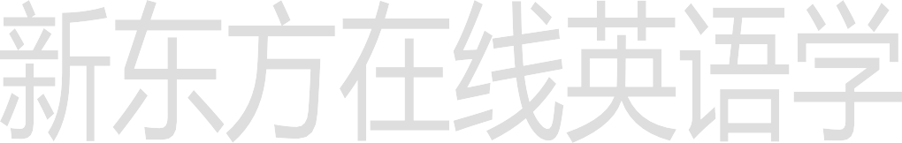roast: 烤的
2. 老张来了！

LaoZhang comes. Lao Zhang is here. Sam is here.

1. Have a cigarette.

抽支烟吧。

have a rest: 休息一下吧have a drink: 喝一杯吧have a seat: 坐吧 …

1. Have a glass of …then. then:
   1. 然后；
   2. 那么。

Then no. 那就算了吧。

# Lesson 81 课文讲解

**Lesson 81 语法讲解**

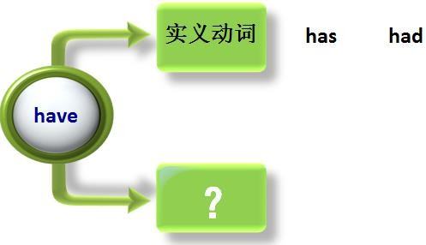

1. 拥有

I have a close friend in Beijing.

我在北京有一个亲密的朋友。

1. have 与生病

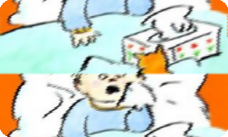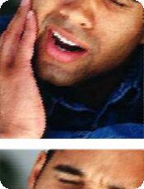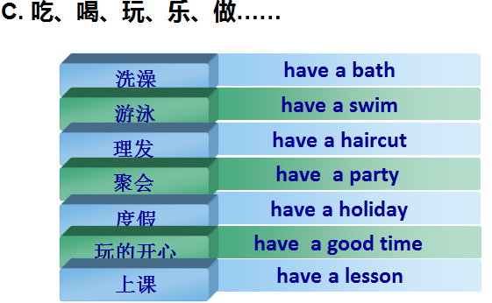

**have a cold**

**have a headache**

**have a toothache**

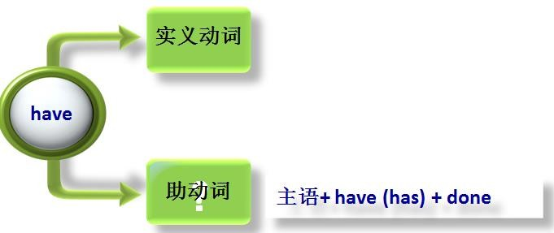

# Lesson 82 单词句型讲解

* 1. breakfast: 早餐fai si te
  2. haircut: 理发

have a haircut

* 1. party: 聚会

dinner party: 宴会

* 1. holiday: 假日

vocation(美式)

have a holiday\ vocation

drink-drank, enjoy-enjoyed yourself, are eating, go for-went for, eat-ate, take

1. They had a meal at a restaurant.

They ate a meal at a restaurant.

1. We had a holiday last month.

We went for a holiday last month.

1. Have a biscuit. take
2. You had a good time. You

a biscuit.

enjoyed yourself.

1. They are having their lunch. They are eating their lunch.
2. I had a glass of milk. I drank a glass of milk.

# Lesson 81&82 知识拓展

【各种烹饪大法】

☻ fried 油炸fu ruai d ☻ roast 烘烤

☻ bake 烘焙bei ke ☻ grill 用（烤架）烤

☻ simmer 炖sei me er ☻ steam 蒸si di me

☻ mash 捣碎mai shi ☻ boil 煮熟bou ai ou

☻ mince/chop 绞碎men si ☻ shell 剥皮

【中国特色食品】

a boiled egg a fried egg a tea egg fried sticks si dei ke si油条

sliced noodles

si lai si de nu dou si

刀削面

steamed bread sweet ball soup fish ball soup

eight treasures porridge sweet potato porridge soybean milk sao ai bin

hot pot 火锅